Capstone 1 Data Storytelling

James Olmstead

**Introduction**

My question for my Capstone project is to see if we can use survey data to create categorize the respondents based on how they answered questions on political preferences in the United States. My Jupyter notebook is a brief exploratory analysis of the data, which has been cleaned in the 'Capstone 1 Cleaning' notebook.

My primary questions I want to answer for this storytelling document are:

1. How are the responses correlated, and what is the strength of the correlations?

2. Which political issues are priorities for the survey respondents?

3. Where do the respondents stand on the major party platforms?

Since most of the data is summarized in the documentation via frequency tables, I hope to study correlations and visualize some key questions in the survey.

**How closely correlated are the responses?**

To answer this question I used the [Cramer’s V](https://en.wikipedia.org/wiki/Cram%C3%A9r%27s_V) statistic for measuring association between nominal variables. I was able to create a matrix for each pairwise association measure and examine the results. One interesting thing I found was that the questions with the highest frequency of counts in the table had to do with watching certain media channels (e.g. Fox, MSNBC) and self-described political ideology (e.g. Conservative, Environmentalist). In fact, the most common questions that were highly correlated were:

1. selfdescr_ccap_7_baseline: Self-identify (or not) as a Conservative

2. selfdescr_ccap_9_baseline: Self-identify (or not) as a Progressive

3. dailytalkshow_1_baseline: Watch the FOX O'Reiley Factor on a regular basis (or not)

4. selfdescr_ccap_5_baseline: Self-identify (or not) as a Liberal

5. enews_show_4_baseline: Watch FOX Special Report with Bret Baier on a regular basis (or not)

6. healthreformbill_2017: Do you think the health care reform bill that passed in 2010 should be expanded, kept the same, or repealed?

7. dailytalkshow_2_baseline: Watch FOX Hannity on a regular basis (or not)

8. redovote2016_2017: If you had the chance to do it again, how would you vote in 2016? (Choices Trump, Clinton, or someone else)

9. Clinton_Cruz_2016: If the 2016 election had been a race between Clinton and Cruz, who would you vote for?

10. teapartsup_baseline: Generally speaking, do you support or oppose the goals of the Tea Party movement?

**Which political issues are priorities for the survey respondents?**

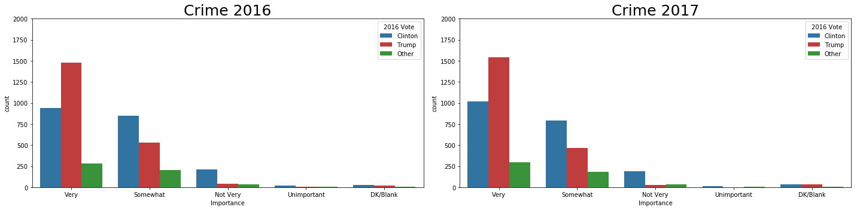For this question I examined a series of questions where respondents rated how important various political issues were to them. For example, someone may rate ‘Social Security’ as ‘Very Important’ or another may rate ‘Climate Change’ as ‘Not Very Important’. I was able to visualize these responses for each of the 23 topics and break them down by year and 2016 vote for President. One of the 23 visualizations is below:

**Where do the respondents stand on the major party platforms?**

To answer this question, I took a look at questions relating to the major party agendas (Democratic and Republican). How do respondents feel about how each party is addressing 12 major issues? And how does it differ between Trump and Clinton voters? Similarly, to the previous section, I was able to break down the results by the parties themselves and by respondents 2016 vote. Note that the party that each person was asked about was randomly assigned. One of these 12 plots is below:

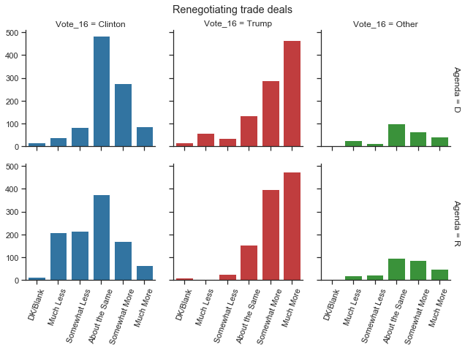

My ‘Data Storytelling’ Jupyter notebook goes into much more detail on additional observations on the results.